TWO POINTERS
TWO SUM(SORTED ARRAY):
import java.util.*;
class sump{
public static void main(String[]args){
int[] arr={2,7,11,15};
int target=9;
int left=0;
int right=arr.length-1;
while(left<right){
int sum=arr[left]+arr[right];
if(sum==target){
System.out.println("Target found");
System.out.println("Number:"+ arr[left] +"and" +arr[right]);
System.out.println("indices:"+ left +"and" +right);
}
if(sum>target){
right--;
}
else{
left++;
}
}
}
}
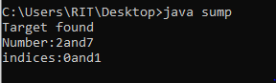
TWO SUM(UNSORTED ARRAY):

import java.util.*;

public class unsorted {
public static void main(String[] args) {
Scanner s = new Scanner(System.in);
System.out.println("Enter n:");
int n = s.nextInt();
int[] arr = new int[n];
System.out.println("Enter values:");
for (int i = 0; i < n; i++) {
arr[i] = s.nextInt();
}
System.out.println("Enter target value:");
int target = s.nextInt();
Arrays.sort(arr);
for(int i=0;i<n;i++)
{
System.out.println(arr[i]);}
int left = 0;
int right = n - 1;
while (left < right) {
int sum = arr[left] + arr[right];
if (sum == target) {
System.out.println(left + "," + right);
return;
} else if (sum < target) {
left++;
} else {
right--;
}
}
System.out.println(-1);
}
}
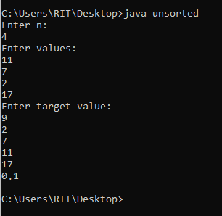
REMOVE DUPLICATES:
import java.util.*;
class duplicate{
public static void main(String[] args){
int[] arr={1,1,2,2,3,3,4};
int i=0;
for(int j=1;j<arr.length;j++){
if(arr[i]!=arr[j]){
i++;
arr[i]=arr[j];
}
}
for(int k=0;k<=i;k++){
System.out.println(arr[k] + " ");
}
}
}
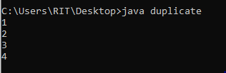
PALINDROME OR NOT
import java.util.*;
class palindrome{
public static void main(String[] args){
Scanner sc=new Scanner(System.in);
System.out.println("enter string:");
String str=sc.nextLine();
int left=0;
int right=str.length()-1;
while(left<right){
if(str.charAt(left)!=str.charAt(right)){
System.out.println("string is a palindrome");
return;
}
left++;
right--;
}
System.out.println("palindrome");
}
}
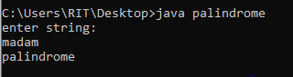
REMOVE ONLY ONE CHARACTER CHECK WHETHER THE INPUT IS PALINDROME OR NOT:

import java.util.*;
public class onepalin {
public static void main(String[] args) {
Scanner sc = new Scanner(System.in);
String str = sc.next();
String ans = "";
for(int k = 0; k < str.length(); k++) {
String temp = str.substring(0,k)
+ str.substring(k+1);
int left = 0;
int right = temp.length()-1;
boolean flag = true;
while(left < right) {
if(temp.charAt(left) != temp.charAt(right)) {
flag = false;
break;
}
left++;
right--;
}
if(flag) {
ans = temp;
}
}
if(ans.equals(""))
System.out.println("Not Palindrome");
else
System.out.println(ans);
}
}